NAME: VENKATRAMAMOORTHY.G
- Create a Project for Online Shopping. Add Products to the Cart and the Count should increase as the Products are added to the Cart.
CODE:
<head>
<style>
ul {
list-style-type: none; display: flex; gap: 30px; }
</style>
</head>
<body>
<h1>SHOPPING CART</h1>
<h2>CART (<span id="cartno">0</span>)</h2>
<ul id="cart">
<li>Good day<button onclick="additeam()">Add to cart</button></li>
<li>Happy Happy<button onclick="additeam()">Add to cart</button></li>
<li>Marry Gold<button onclick="additeam()">Add to cart</button> </li>
<li>Tiger<button onclick="additeam()">Add to cart</button></li>
<li><button onclick="clear1()">clear all</button></li></ul>
<div><p>copyright @ INDEW 2026</p></div>
<script>
let ul=document.getElementById('cart');
let value=document.getElementById('cartno');
let cart= value.textContent;
cart=Number(cart);
function additeam(){
cart++;
value.textContent=cart;
}
function clear1(){
cart=0;
value.textContent=cart;
}
</script>
</body>
OUTPUT:
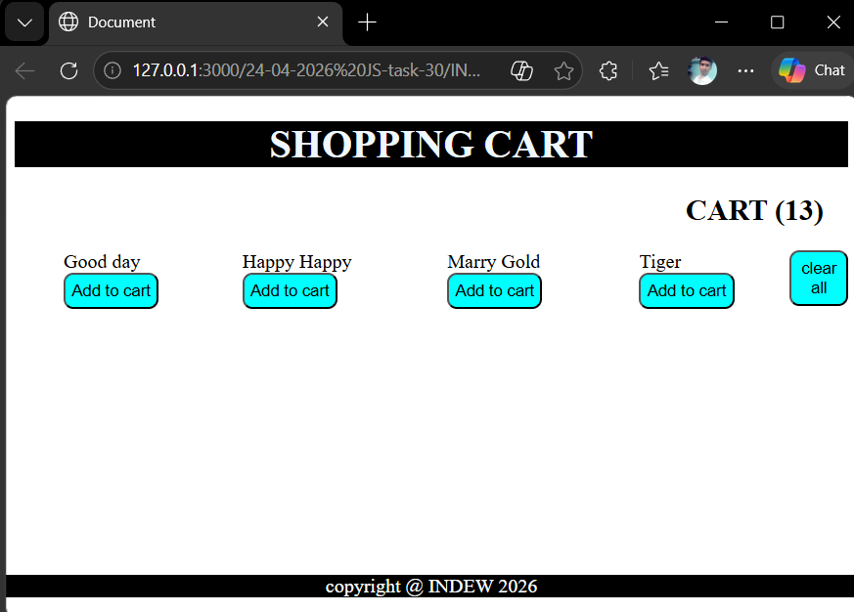
- Write a function that accepts a callback.
CODE:
function greet(name,callback){
console.log(`Hi, ${name}`);
callback(name);
}
function sayhi(name){
console.log(`hello ${name} it's a call back function`)
}
greet('venkat',sayhi);
OUTPUT:
